|  |  |  |
| --- | --- | --- |
| First Name | Matheson | |
| Last Name | Irinco | |
| Address | 1036 Hernan Cortes St., Subangdaku, Mandaue City, Cebu | |
| Cell Phone | 09509725508 |
| Email | irincomatheson@e-formula.com | |
|  | | |

**I. Personal Info**

**II. Unit Info**

|  |  |
| --- | --- |
| Unit - ID | **N/A** |
| Brand/Model | **ASPIRE A514-54G** |
| S/N | **NXA1XSP00205005E0C3400** |
| SNID | **05002407634** |
| Operating System | **Windows 10 Home Single Language 64-bit(10.0,Build 19042)** |
| Mac Address | **68-3E-26-0F-D0-11** |
| Software Installed | **MS OFFICE, AUTOCAD, VIBER, ZOOM** |

**INSTRUCTIONS**

1. Unit ID



Unit ID tag

1. Brand/Model

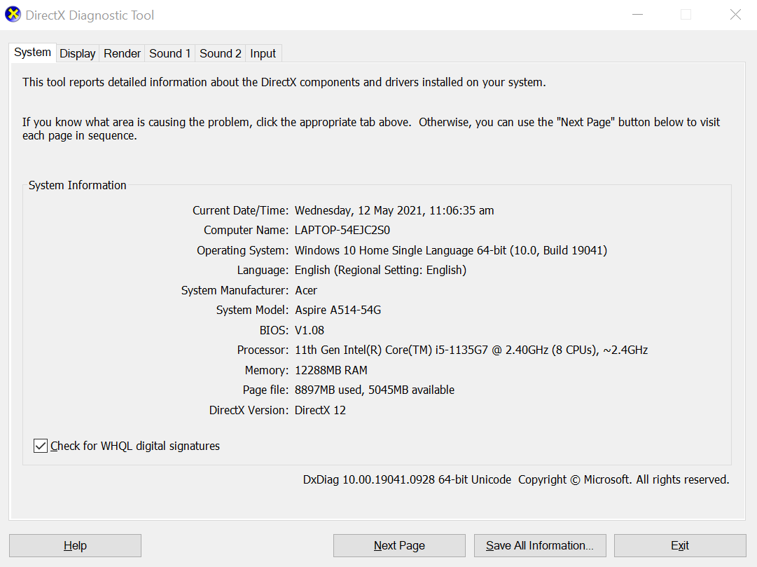

Brand/Model: Acer/Aspire A514 54G

Open DirectX Diagnostic Tool (dxdiag)

-Click + R to Open *RUN*

-Type “dxdiag” and Hit Enter/OK

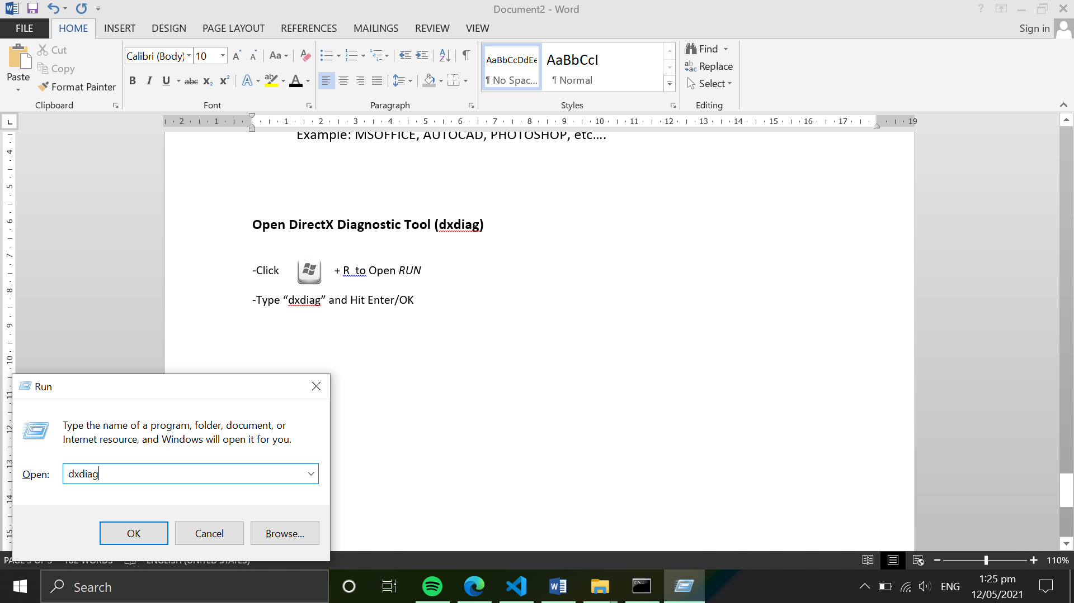

1. S/N
2. SNID

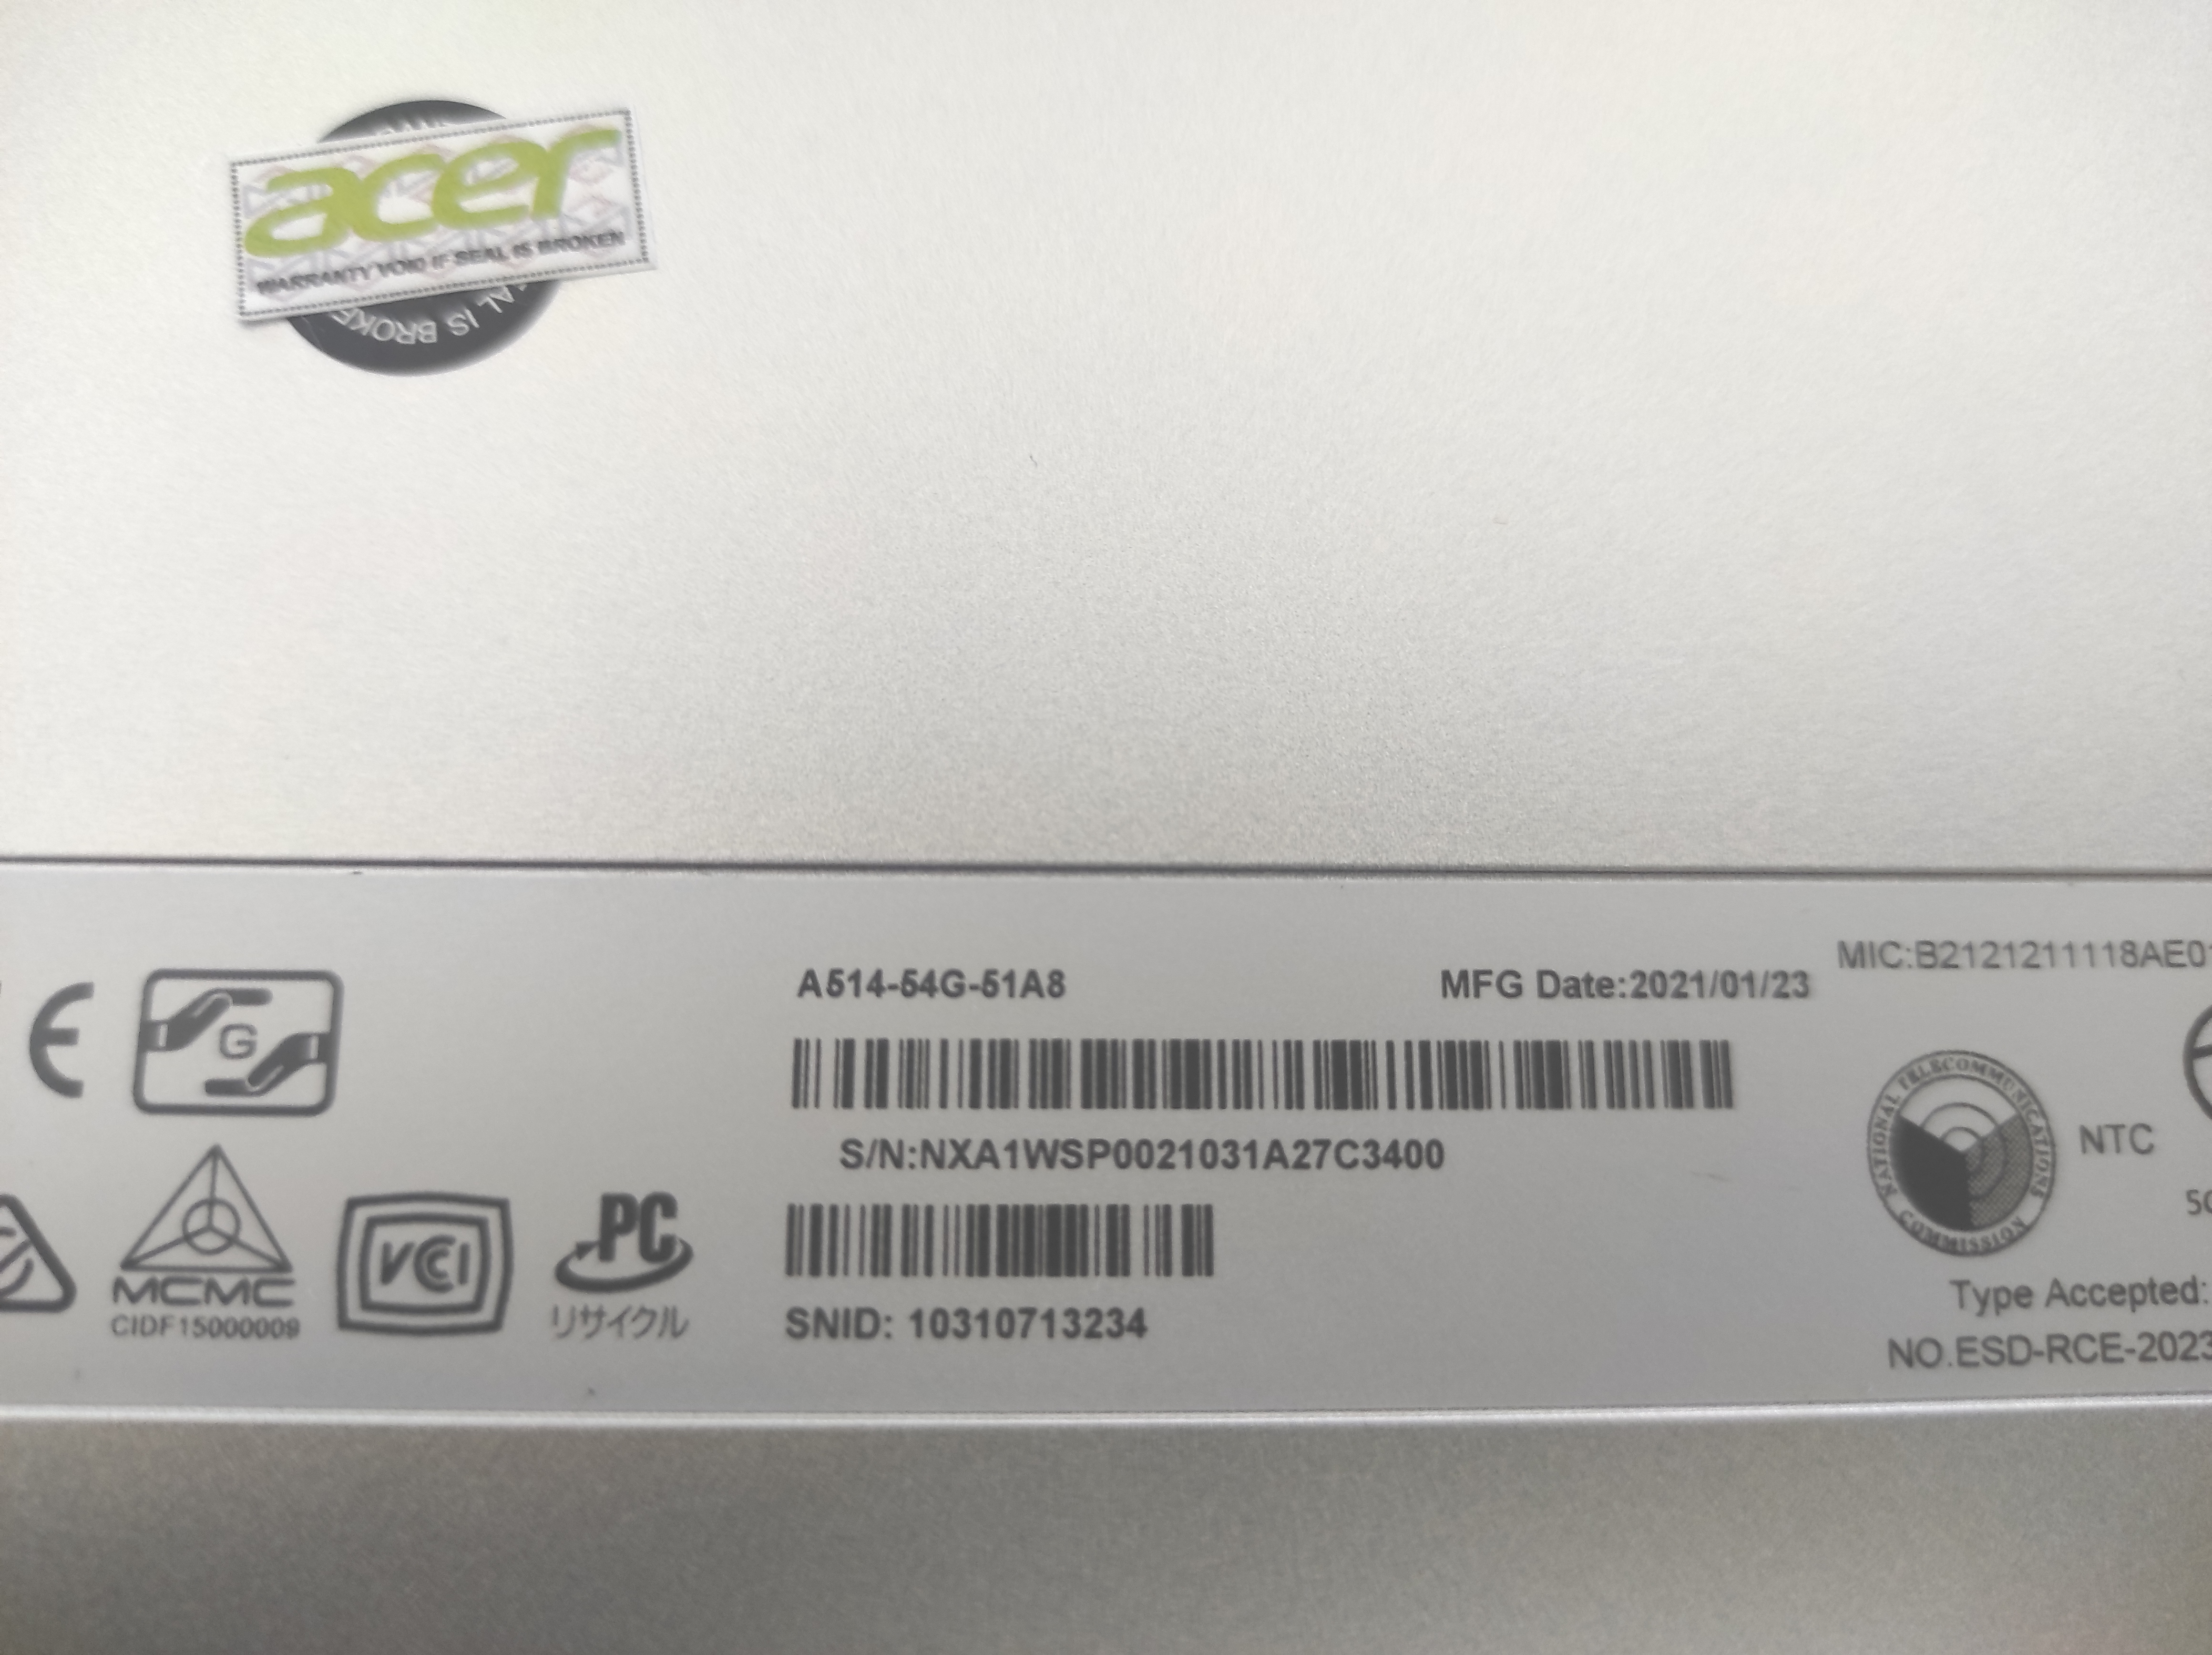

*Note:*

*S/N* and *SNID* sticker located under your device/unit

3. S/N: NXA1WSP002103A27C3400

4. SNID: 10310713234

1. Operating System



5. Operating System:Windows 10 Home

Open DirectX Diagnostic Tool (dxdiag)

-Click + R to Open *RUN*

-Type “dxdiag” and Hit Enter/OK



1. Mac Address

Open Command Prompt (CMD)

Option 1

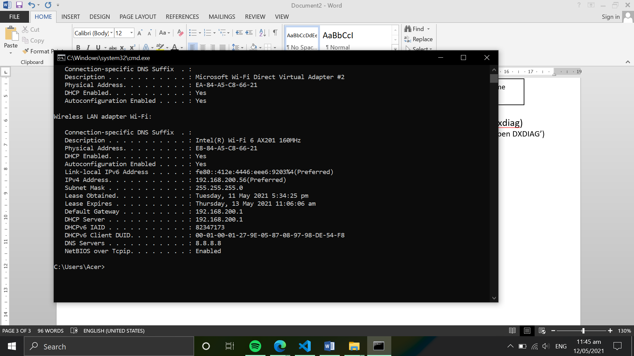 -Click Start

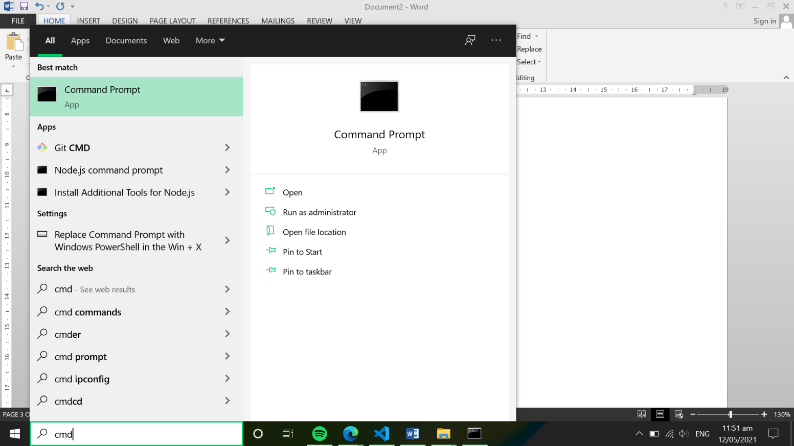

-Search for “CMD”

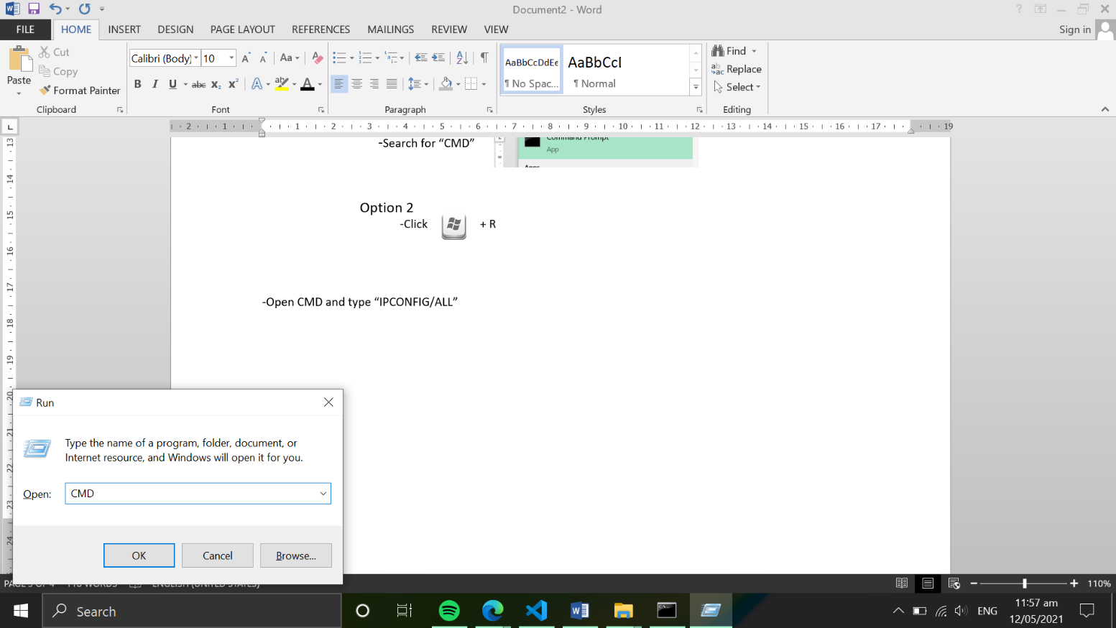

 Option 2

-Click + R to Open *RUN*

-Type “CMD” and Hit Enter/OK

-Open CMD and type “IPCONFIG/ALL”

-Locate “Wireless Lan adapter Wi-Fi” and under it “Physical Address”



6. Mac Address: E8-84-A5-C8-66-21

Note:

Physical Address is other term for Mac Address (Physical Address = Mac Address)

1. Software Installed

List of all Software Application installed in device/unit

Example: MSOFFICE, AUTOCAD, PHOTOSHOP, etc….

-After you fill up the form, save it as “(LastName,FirstName).docx”

Note: For any Question/Clarification, Please message me on Viber.

Contact Info:

Mhar Adrian Mateo

09753013256